  - Warming Up Exercise:
In this exercise, you’ll work with daily time allocation data recorded by a group of students. Each student tracked the number of hours spent studying, watching entertainment, and sleeping for 15 consecutive days.
• Dataset: Each record represents one day’s data in the format:
(study hours,entertainment hours,sleep hours) • A sample dataset is provided below.
Daily Student Productivity Data
# Daily time (in hours): [study, entertainment, sleep] time_data = [
(3.5, 2.0, 7.0), (5.0, 1.5, 6.5), (2.5, 3.0, 8.0),
(4.0, 2.0, 6.0), (1.5, 4.5, 9.0), (3.0, 2.5, 7.5),
(5.5, 1.0, 6.0), (2.0, 3.5, 8.5), (4.5, 2.0, 7.0),
(3.0, 3.0, 7.5), (6.0, 1.5, 6.0), (2.5, 4.0, 8.0),
(4.0, 2.5, 7.0), (5.0, 2.0, 6.5), (3.5, 2.5, 7.0)
]
Complete all the tasks below:
Task 1. Classify Study Time:
    - Create empty lists for study time classifications:
      - Low: less than 3 hours.
      - Moderate: between 3 and 5 hours.
      - High: more than 5 hours.
    - Iterate over the time_data list and add each study hour to the appropriate category.
    - Print the lists to verify the classifications.

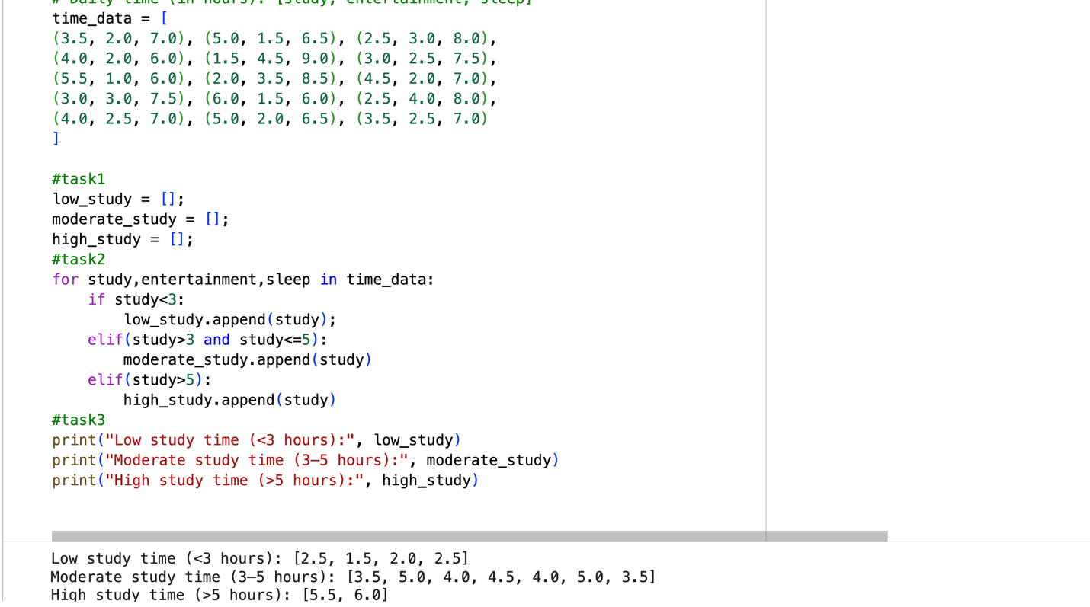

Task 2. Based on Data – Answer all the Questions:
1. How many days had low study time?
      - Hint: Count the number of items in the low study list and print the result.
    - How many days had moderate study time?
    - How many days had high study time?
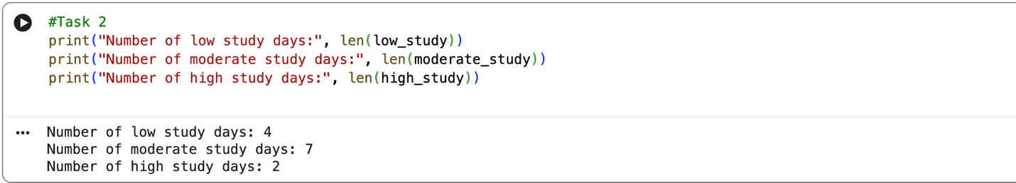

Task 3. Convert Study Hours to Minutes:
Convert each study hour value into minutes and store it in a new list called study_minutes.
Formula: Minutes = Hours× 60
    - Iterate over the time_data list and apply the formula to the study hours.
    - Store the results in the new list.
    - Print the converted values.
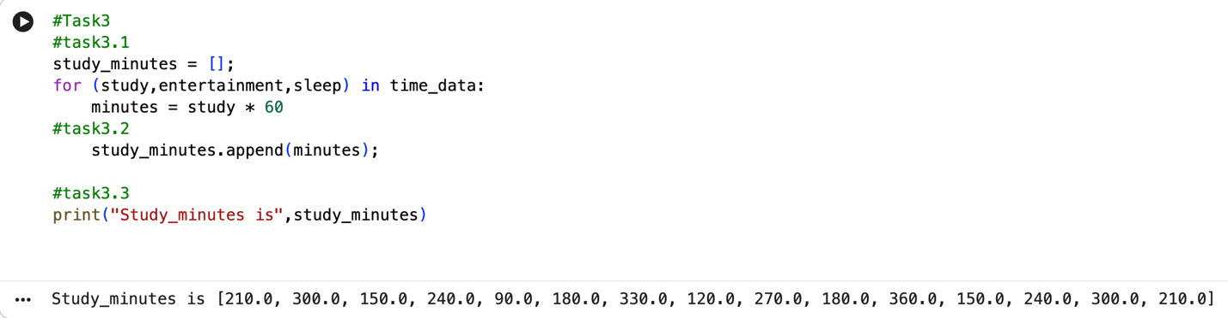
Task 4. Analyze Average Time Use:
Scenario: Each record contains daily hours of study, entertainment, and sleep.
    - Create empty lists for study_hours, entertainment_hours, and sleep_hours.
    - Iterate over time_data and extract values into each list.
    - Calculate and print:
      - Average hours spent studying.
      - Average hours spent on entertainment.
      - Average hours spent sleeping.
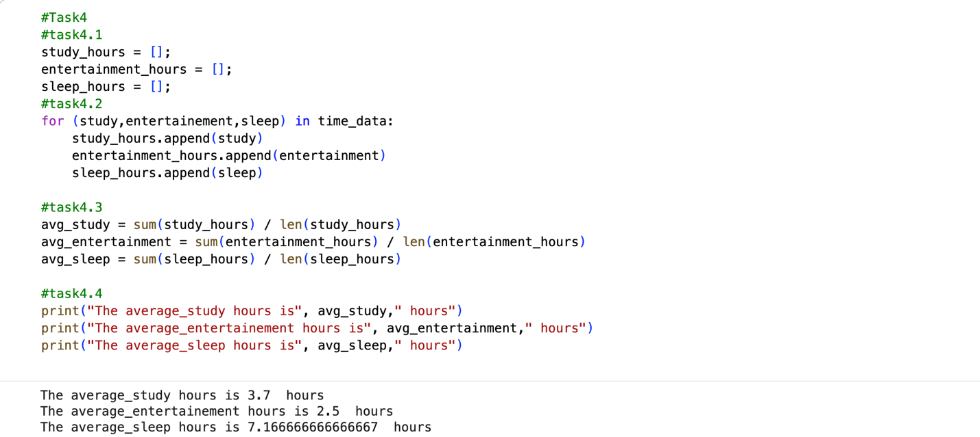
Task 5. Visualization - Study vs Sleep Pattern:
    - Import matplotlib.pyplot as plt.
    - Plot a scatter plot with:
      - x-axis: Study hours
      - y-axis: Sleep hours
    - Add labels, title, and color.
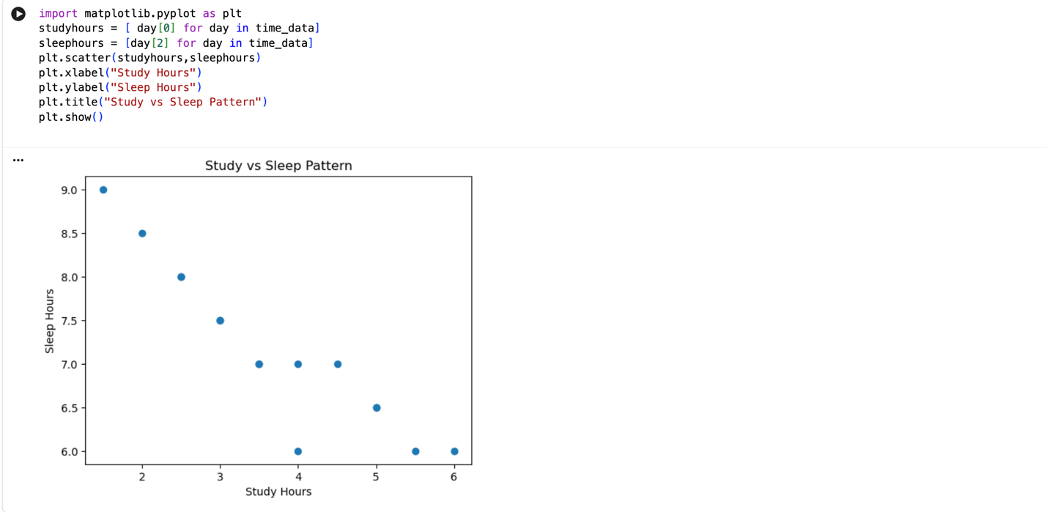
- Problem based on Popular Algorithm.
  - Recursion:
- Definition:
Recursion is a programming technique where a function calls itself to solve a problem. It’s typically used when a problem can be broken down into smaller, similar sub-problems. Some key concepts in Recursion:
      - Base Case: This is the condition where the recursive calls stop. It prevents infinite loops by returning a value without further recursion.
      - Recursive Case: This is the part where the function calls itself with a modified argument, gradually moving towards the base case.
      - Stack Memory: Each recursive call adds a layer to the call stack. Too many recursive calls without reaching a base case can lead to a ”stack overflow” error due to memory limits.
Example: A classic recursive example is the factorial of a number:
Sample Code - Reccursive Approach for finding factorial of a Number.
def factorial(n):
"""
Calculate the factorial of a non-negative integer n.
The factorial of a number n (denoted n!) is the product of all positive integers less than or equal to n.
Specifically:
- If n is 0, the factorial is defined as 1 (base case).
- For any positive integer n, the factorial is calculated recursively as n * (n-1) * (n-2) * ... * 1.
Args: n (int): A non-negative integer for which to calculate the factorial.
Returns: int: The factorial of the input number n.
Raises:
ValueError: If the input n is a negative integer, as factorial is only defined for non-negative integers.
"""
if n == 0: # Base case return 1
else: # Recursive case return n * factorial(n - 1)
- General Algorithm for Recursion Problems: • Identify the Base Case: Determine the simplest form of the problem. This is crucial to avoid infinite recursion.
      - Divide the Problem: Think about how to reduce the problem’s size. Often, the problem should become simpler with each recursive call.
      - Formulate the Recursive Case: Decide how each recursive step will bring you closer to the base case.
      - Combine Results: If necessary, think about how to combine the results of recursive calls to form the final result.
- How to Identify Recursion-Based Problems:
1. Problem Can Be Split into Smaller Versions of Itself: • If the problem can be divided into smaller sub-problems that resemble the original, recursion might be suitable.
• Example: Summing all numbers in a nested list. Each sub-list can be treated as a smaller instance of the original list.
2. Tasks with Nested or Hierarchical Structures:
        - Problems involving nested data structures, like nested lists or tree structures, are often recursive by nature.
        - Example: Calculating the size of a directory with subdirectories.
3. Repetitive or Iterative Nature with Reducing Input: • Problems that involve performing an operation repeatedly with a progressively smaller (or simpler) input are ideal candidates.
• Example: Calculating the power of a number, where the exponent decreases with each call
- Problems Involving Dividing and Conquering: • When a problem can be divided into parts that can be solved independently, recursion is often useful, as seen in sorting and search algorithms like quicksort and binary search.
8.1.1 Exercise - Recursion:
Task 1 - Sum of Nested Lists:
Scenario: You have a list that contains numbers and other lists of numbers (nested lists). You want to find the total sum of all the numbers in this structure. Task:
• Write a recursive function sum_nested_list(nested_list) that:
        - Takes a nested list (a list that can contain numbers or other lists of numbers) as input.
        - Sums all numbers at every depth level of the list, regardless of how deeply nested the numbers are.
      - Test the function with a sample nested list, such as nested_list = [1, [2, [3, 4], 5], 6, [7, 8]].
The result should be the total sum of all the numbers.
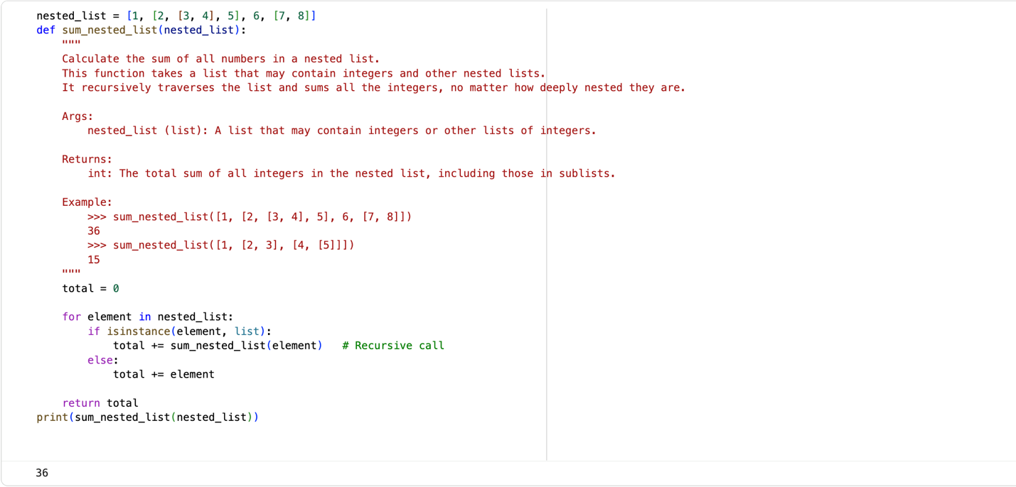
Sample Code - Sum of Nested lists.
def sum_nested_list(nested_list):
"""
Calculate the sum of all numbers in a nested list.
This function takes a list that may contain integers and other nested lists.
It recursively traverses the list and sums all the integers, no matter how deeply nested they are.
Args: nested_list (list): A list that may contain integers or other lists of integers.
Returns:
int: The total sum of all integers in the nested list, including those in sublists . Example:
>>> sum_nested_list([1, [2, [3, 4], 5], 6, [7, 8]])
36
>>> sum_nested_list([1, [2, 3], [4, [5]]]) 15
"""
total = 0 for element in nested_list:
if isinstance(element, list): # Check if the element is a list total += sum_nested_list(element) # Recursively sum the nested list
else: total += element # Add the number to the total return total
Task 2 - Generate All Permutations of a String:
Scenario: Given a string, generate all possible permutations of its characters. This is useful for understanding backtracking and recursive depth-first search. Task:
      - Write a recursive function generate_permutations(s) that:
– Takes a string s as input and returns a list of all unique permutations.
• Test with strings like ”abc” and ”aab”.
print(generate_permutations("abc"))
# Should return [’abc’, ’acb’, ’bac’, ’bca’, ’cab’, ’cba’]
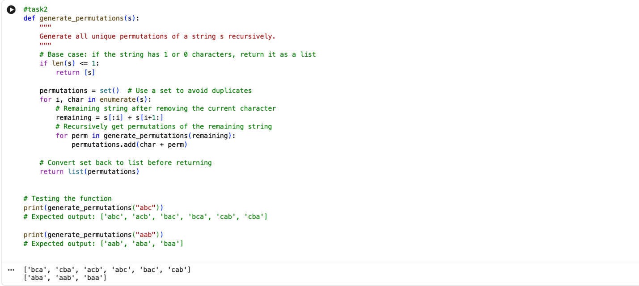
Task 3 - Directory Size Calculation:
Directory Size Calculation Scenario: Imagine a file system where directories can contain files (with sizes in KB) and other directories. You want to calculate the total size of a directory, including all nested files and subdirectories.
Sample directory structure.
# Sample directory structure directory_structure = {
"file1.txt": 200,
"file2.txt": 300,
"subdir1": {
"file3.txt": 400,
"file4.txt": 100
},
"subdir2": {
"subsubdir1": {
"file5.txt": 250
},
"file6.txt": 150
}
}
Task:
1. Write a recursive function calculate_directory_size(directory) where:
        - directory is a dictionary where keys represent file names (with values as sizes in KB) or directory names (with values as another dictionary representing a subdirectory).
        - The function should return the total size of the directory, including all nested subdirectories.
        - T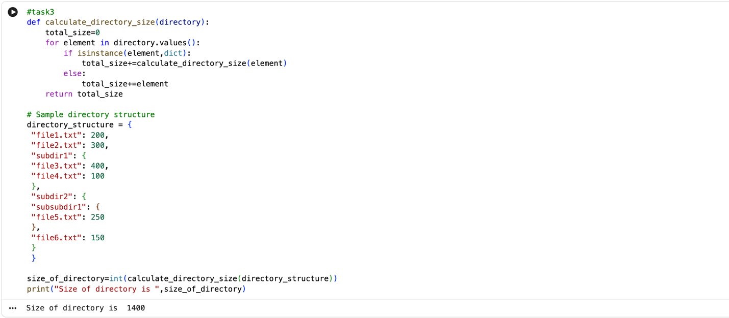est the function with a sample directory structure.

8.2 Dynamic Programming:
- Introduction to Dynamic Programming:
Dynamic Programming is a method used for solving problems that can be broken down into smaller sub-problems. It is particularly useful when the problem exhibits overlapping sub-problems and optimal substructure.
• Overlapping Sub problems: This property occurs when the problem can be divided into smaller sub problems, and these sub problems are solved multiple times. • Optimal Substructure: The optimal solution to the problem can be constructed from optimal solutions to its sub-problems.
- Type of Dynamic Programming:
  - Memoization: A top-down approach where we solve the problem by breaking it into sub-problems, and store the results of sub-problems to avoid redundant computations.
  - Tabulation: A bottom-up approach that starts solving from the smallest subproblem, and progressively solves larger sub-problems while storing results in a table.
- Steps in Dynamic Programming:
  - Define the subproblem: Break the original problem into smaller sub-problems.
  - Recursive Relation: Identify the relation between sub-problems (i.e., how to compute the solution of the problem based on the solutions to smaller sub-problems).
  - Store the results: Cache or store results of sub-problems to avoid recalculating them (memoization or tabulation).
  - Build the final solution: Combine the solutions of sub-problems to get the solution to the original problem.
- Example:
Fibonacci Sequence: The Fibonacci sequence is defined as:
  F(0)  F(1)  F(n) | = 0  = 1  = F(n − 1) + F(n − 2) | for n > 1 | (1)
Solving Fibonacci Sequnce with Memoization {Top - Down Approach}.
def fibonacci(n, memo={}):
"""
Computes the nth Fibonacci number using memoization to optimize the recursive solution.
This function uses memoization to store previously computed Fibonacci numbers, reducing redundant calculations and improving performance.
Parameters:
n (int): The index in the Fibonacci sequence for which the value is to be computed. Must be a non-negative integer. memo (dict, optional): A dictionary used to store previously computed Fibonacci values.
It is initialized as an empty dictionary by default and is used during the recursive calls to avoid recalculating results. Returns:
int: The nth Fibonacci number.
Example:
>>> fibonacci(5)
5
>>> fibonacci(10)
55
Time Complexity:
- The time complexity is O(n) because each Fibonacci number is computed only once.
Space Complexity:
- The space complexity is O(n) due to the memoization dictionary storing the results.
"""
if n in memo: return memo[n] if n <= 1:
return n
memo[n] = fibonacci(n - 1, memo) + fibonacci(n - 2, memo) return memo[n]
Solving Fibonacci Sequnce with Tbulation {Bottom - Up Approach}.
def fibonacci(n): """
Computes the nth Fibonacci number using dynamic programming to optimize the solution.
This function uses a bottom-up dynamic programming approach to calculate the nth
Fibonacci number by iteratively building up an array of Fibonacci numbers up to n, thus eliminating
redundant calculations and optimizing performance.
Parameters:
n (int): The index in the Fibonacci sequence for which the value is to be computed.
Must be a non-negative integer.
Returns:
int: The nth Fibonacci number.
Example:
>>> fibonacci(5)
5
>>> fibonacci(10)
55
Time Complexity:
- The time complexity is O(n), as the function iterates through the range 2 to n, calculating
each Fibonacci number once.
Space Complexity:
- The space complexity is O(n), due to the array used to store the Fibonacci numbers
up to n.
"""
if n <= 1:
return n
dp = [0] * (n + 1) dp[1] = 1 for i in range(2, n + 1):
dp[i] = dp[i - 1] + dp[i - 2]
return dp[n]
- Tips for Identifying DP Problems: • Overlapping Sub-problems: If a problem requires solving the same subproblem multiple times, it is a good candidate for DP.
  - Optimal Substructure: If an optimal solution can be constructed from the optimal solutions to sub-problems, the problem might be solvable using DP.
  - Recursive Structure: If the problem can be expressed recursively, check if storing intermediate results helps in improving efficiency.
8.2.1 Exercises - Dynamic Programming:
Task 1 - Coin Change Problem:
Scenario: Given a set of coin denominations and a target amount, find the minimum number of coins needed to make the amount. If it’s not possible, return - 1. Task:
  - Write a function min_coins(coins, amount) that: • Uses DP to calculate the minimum number of coins needed to make up the amount.
  - Test with coins = [1, 2, 5] and amount = 11. The result should be 3 (using coins
[5, 5, 1]).
Sample Code - Coin Change Problem.
def min_coins(coins, amount):
"""
Finds the minimum number of coins needed to make up a given amount using dynamic programming.
This function solves the coin change problem by determining the fewest number of coins from a given set of coin denominations that sum up to a target amount. The solution uses dynamic programming(tabulation) to iteratively build up the minimum number of coins required for each amount.
Parameters:
coins (list of int): A list of coin denominations available for making change. Each coin denomination is a positive integer.
amount (int): The target amount for which we need to find the minimum number of coins . It must be a non-negative integer.
Returns:
int: The minimum number of coins required to make the given amount.
If it is not possible to make the amount with the given coins, returns -1. Example:
>>> min_coins([1, 2, 5], 11)
3
>>> min_coins([2], 3)
-1
""" dp = [float(’inf’)] * (amount + 1) dp[0] = 0
for coin in coins:
for i in range(coin, amount + 1):
dp[i] = min(dp[i], dp[i - coin] + 1) return dp[amount] if dp[amount] != float(’inf’) else -1
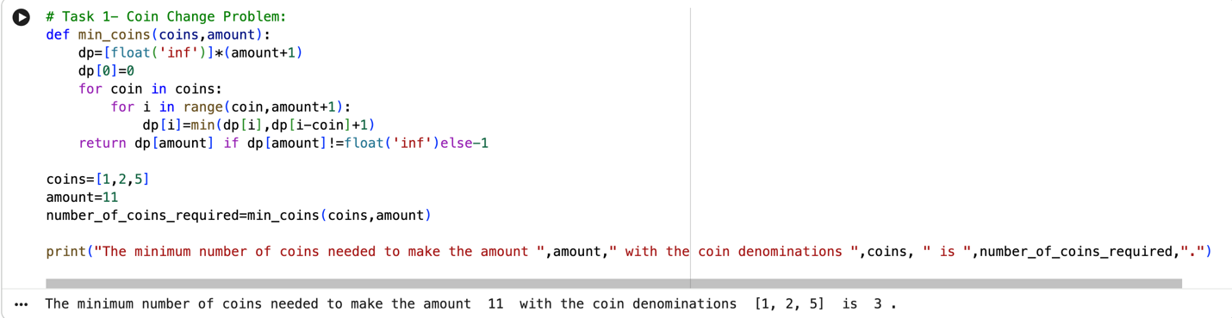
Task 2 - Longest Common Subsequence (LCS):
Scenario: Given two strings, find the length of their longest common subsequence (LCS). This is useful in text comparison. Task:
- Write a function longest_common_subsequence(s1, s2) that:
• Uses DP to find the length of the LCS of two strings s1 and s2.
- Test with strings like "abcde" and "ace"; the LCS length should be 3 ("ace").
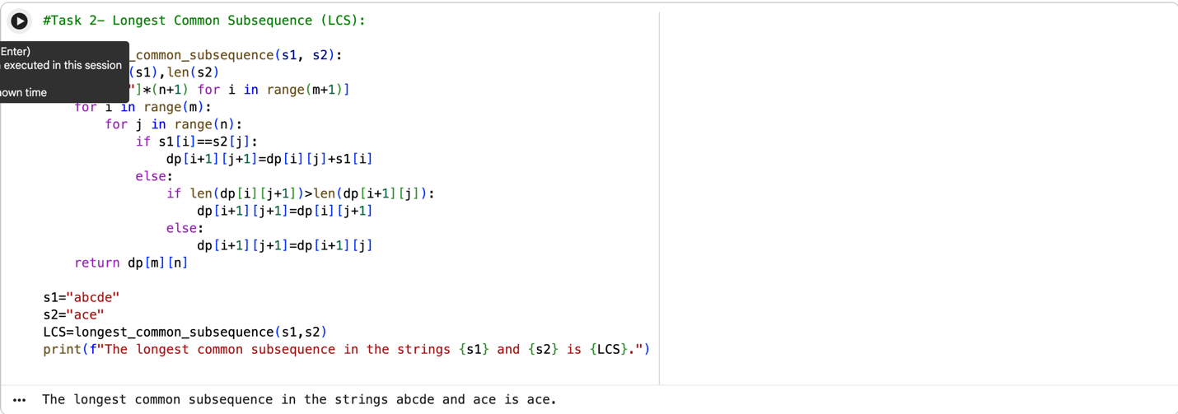
Task 3 - 0/1 Knapsack Problem:
Scenario: You have a list of items, each with a weight and a value. Given a weight capacity, maximize the total value of items you can carry without exceeding the weight capacity. Task:
- Write a function knapsack(weights, values, capacity) that: • Uses DP to determine the maximum value that can be achieved within the given weight capacity.
- Test with weights [1, 3, 4, 5], values [1, 4, 5, 7], and capacity 7. The result should be 9.
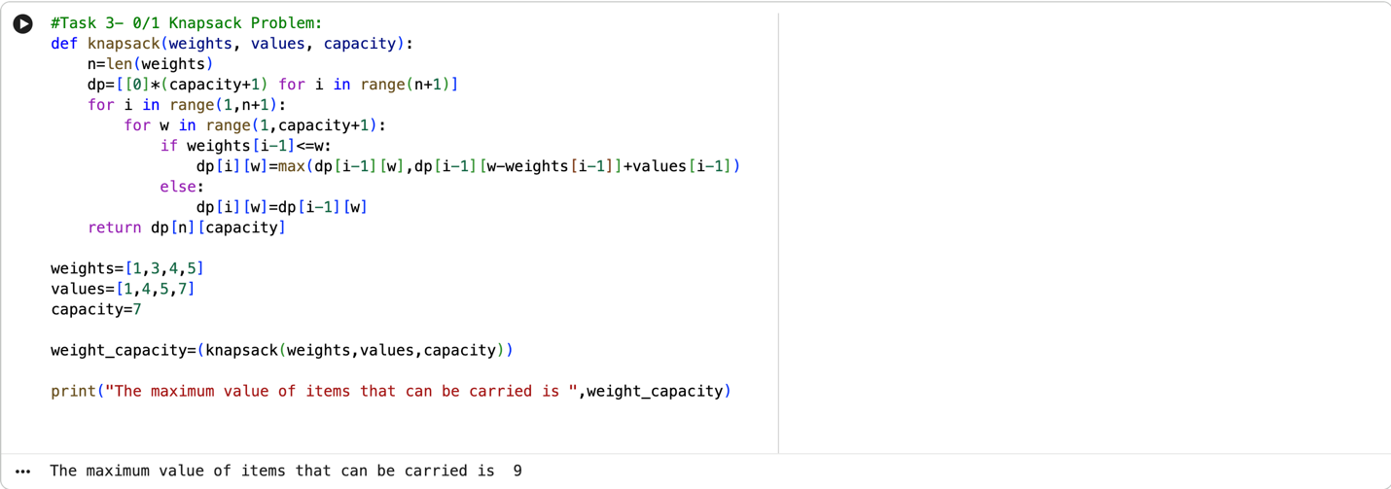
9 Closing Remarks on Recursive and Dynamic Algorithm.
Dynamic Programming (DP) and recursion are both techniques used to solve problems by breaking them down into smaller sub-problems. However, they differ significantly in how they approach problem-solving and how efficiently they execute. Here’s a comparison of both approaches:
- Problem Solving Approach:
  - Recursion:
    - Recursion is generally easier to implement when solving problems with a clear recursive structure, like tree traversal or calculating factorials.
    - It is suitable for problems where each subproblem is independent and doesn’t need to store its results for reuse.
  - Dynamic Programming:
    - DP is used for problems that have optimal substructure and overlapping subproblems. It’s more complex to implement than simple recursion because it requires designing a table or memoization structure.
    - DP is more suitable for optimization problems, like shortest path problems, knapsack problems, etc., where storing intermediate results is crucial for efficient computation.
- When to Use Which?
  - Use Recursion:
    - When the problem naturally fits a recursive structure and does not involve overlapping sub-problems.
    - When the problem has a small problem size (so the overhead of recursion is minimal) or when an elegant, simple solution is needed without worrying about performance.
    - Examples: Tree traversal, divide-and-conquer algorithms (like merge sort).
  - Use Dynamic Programming:
    - When the problem involves overlapping sub-problems and optimal substructure.
    - When you need to optimize recursive solutions to avoid redundant work.
    - Examples: Knapsack problem, Fibonacci sequence, shortest path algorithms (e.g., Dijkstra’s, Bellman-Ford).
————————– Fasten Your Seat Belt and Enjoy the Ride. ————————-

